**Step 1:** Login into the AWS account. Go to Amazon S3 services and click on Create Bucket.

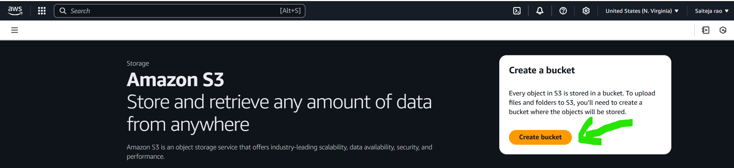

**Step 2:** Now give the name of the bucket ( Bucket name should be globally unique across all AWS accounts because S3 is a global service, and bucket names are part of a public endpoint)

**Step 3:** Now, Disable “**Block all public access**,” which is enabled by default. You can choose the default option if you don’t want users to access your files hosted on the S3 bucket. But in our case, we are hosting a static website on S3 and want to allow users to access it. For that, we need to unselect the block option and click create bucket.

**Blocked all public access (default):**

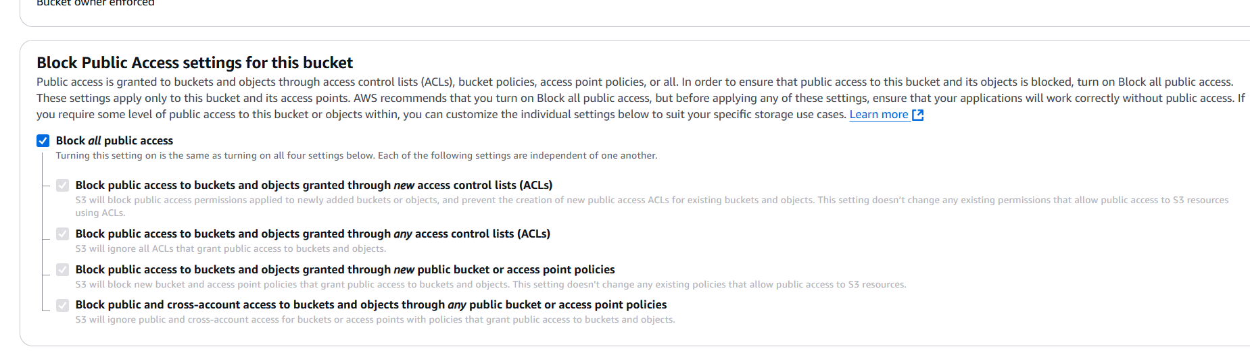

**Hosting static website unselect the block option and select the acknowledge:**

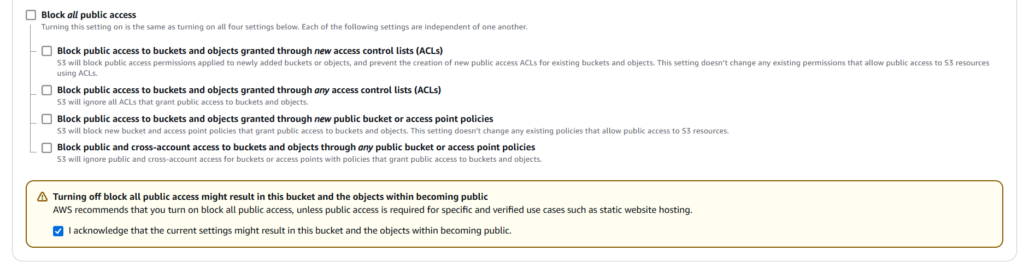

**Step 4:** Now we created S3 Bucket successfully. Now click on that bucket then you can see the Upload option click on it.

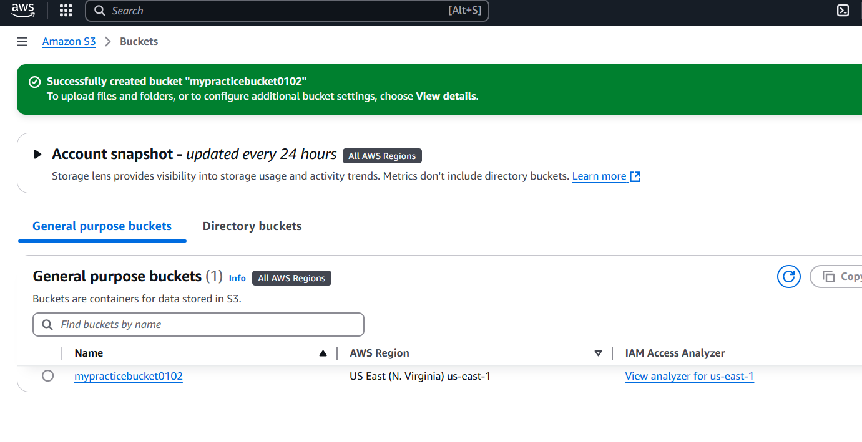

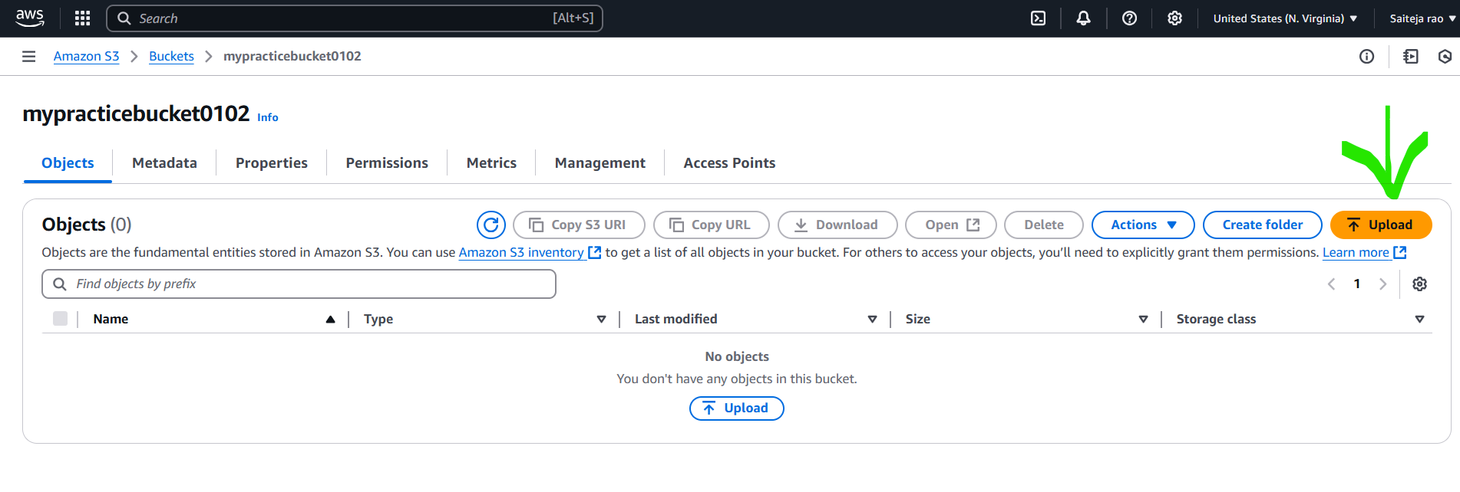

**Step 5:** Now download a sample website template from the browser**.** Search **“html website templates free**” and download it. Once downloaded select the folder and select Extract All then upload all files in the S3 bucket.

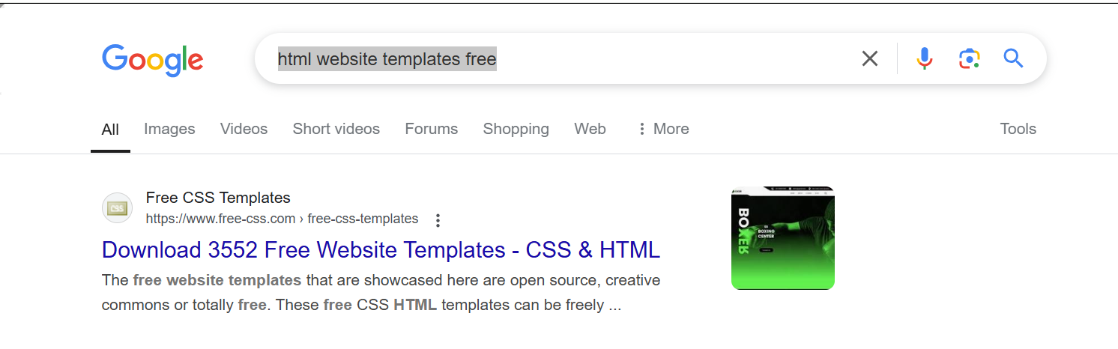

**Step 6:** Now click the upload option then click add files then upload extracted files.

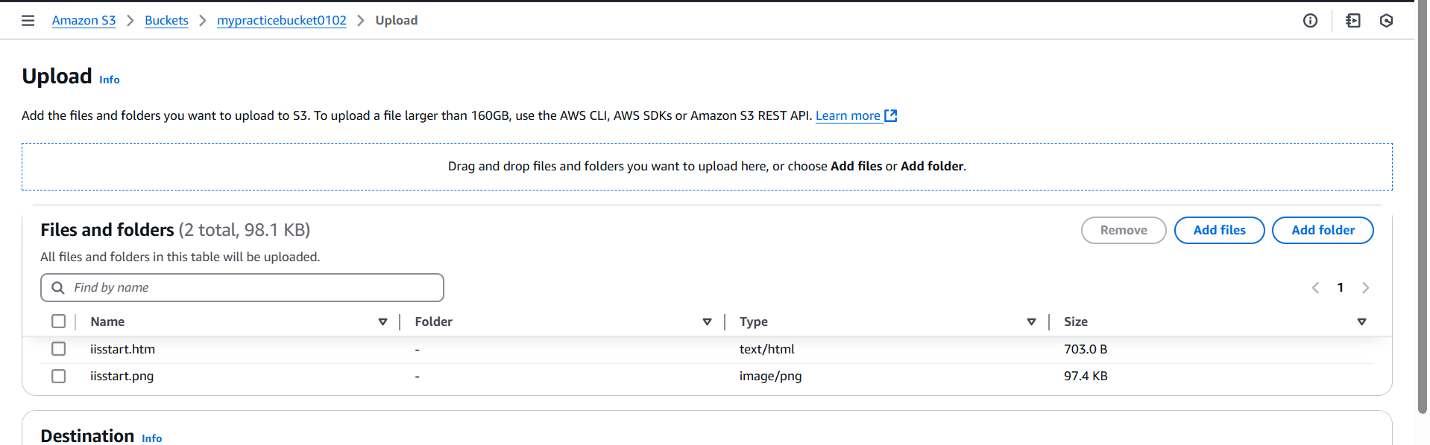

**Step 7:** Once it is saved go to the permissions it is at the top then go to bucket policy click on edit then add the below-mentioned Jason format and save it.

This **S3 bucket policy** allows **public read access** to all objects inside the bucket

**Why do we need this policy?**

* When hosting a **static website** in S3, the website files (HTML, CSS, images) must be **publicly accessible** so that anyone can view them in a browser.
* Without this policy, users trying to open your website will get a **403 Forbidden error** because S3 blocks public access by default.

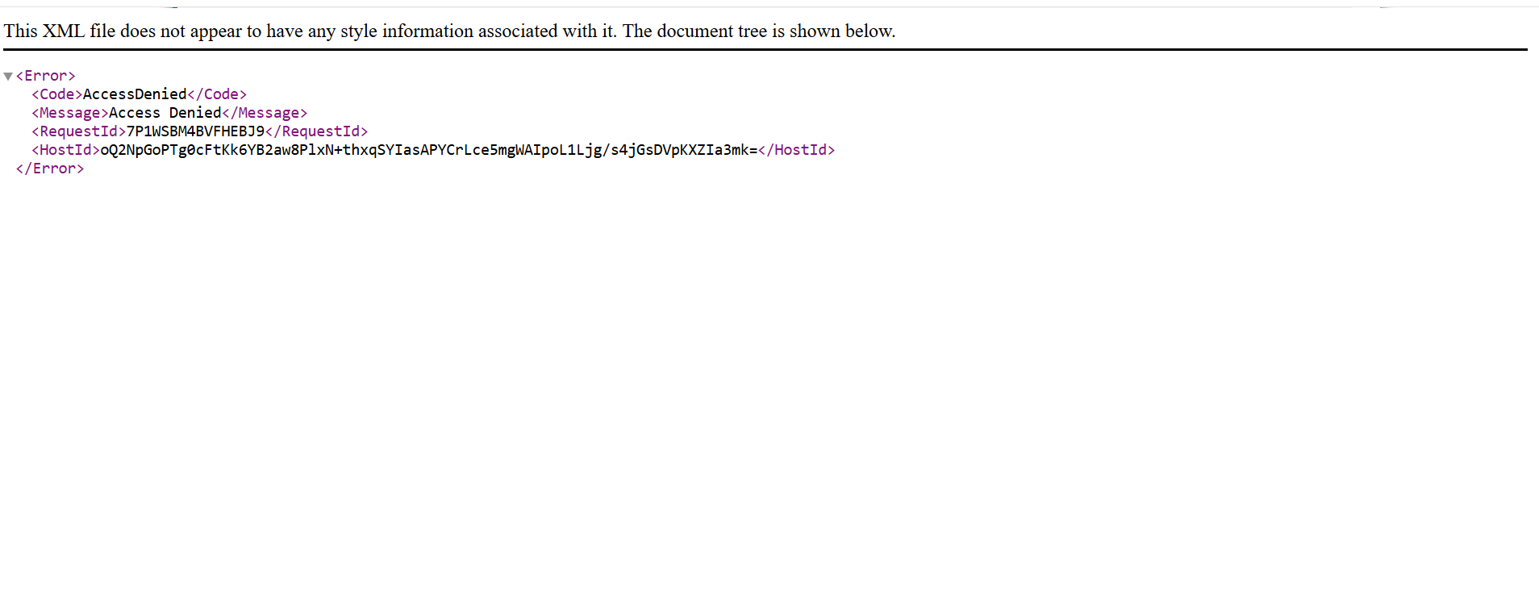

**What happens if we don’t use this policy?**

* Visitors will **not be able to see your website** because they won't have permission to access the files.
* Only the **bucket owner** can access the objects, unless other permissions (like IAM roles or ACLs) are set.

So, this policy is required **only if** you want to make your website files public for everyone.

{

"Version": "2012-10-17",

"Statement": [

{

"Sid": "PublicReadGetObject",

"Effect": "Allow",

"Principal": "*",

"Action": "s3:GetObject",

"Resource": "arn:aws:s3:::mypracticebucket0102/*"

}

]

}

**Note:** In the above policy under Resource mention your bucket name which in mentioned in above in bucket policy as Bucket ARN

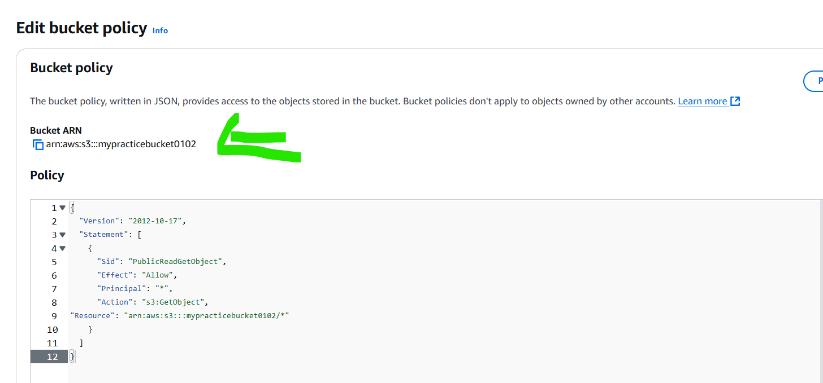

Step 8: Now go back to files where you stored in the s3 bucket and select Html file and click on copy URL and got to new browser and paste it then sample static website is hosted on S3😊⭐

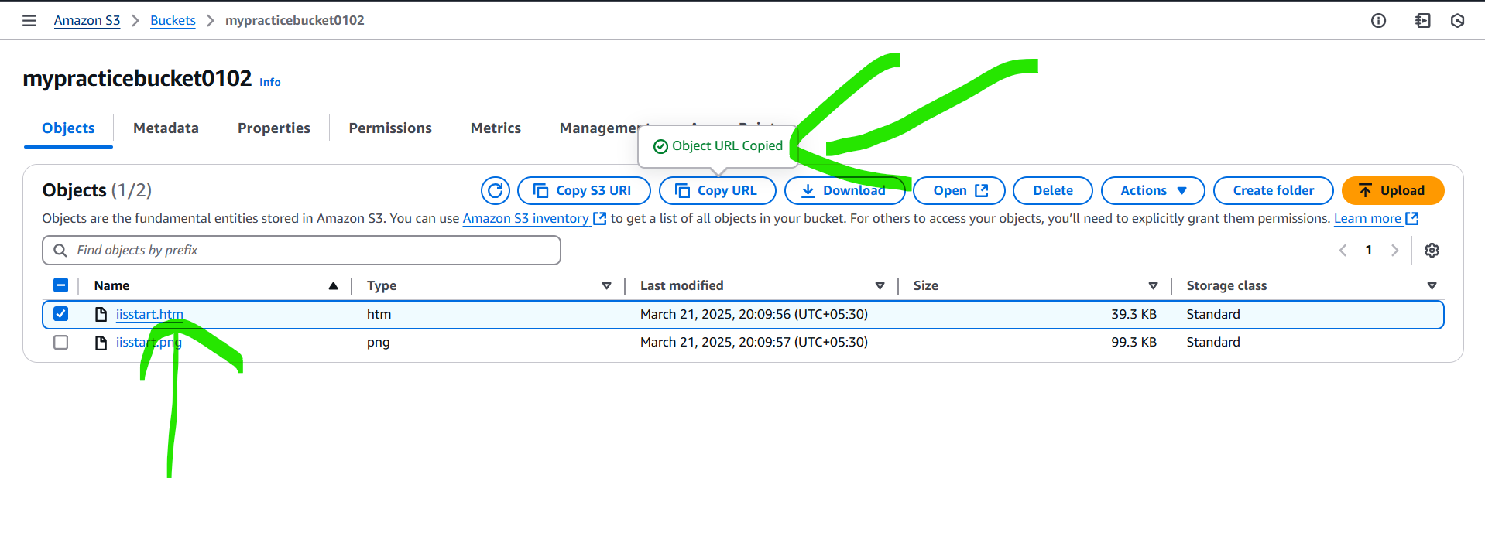

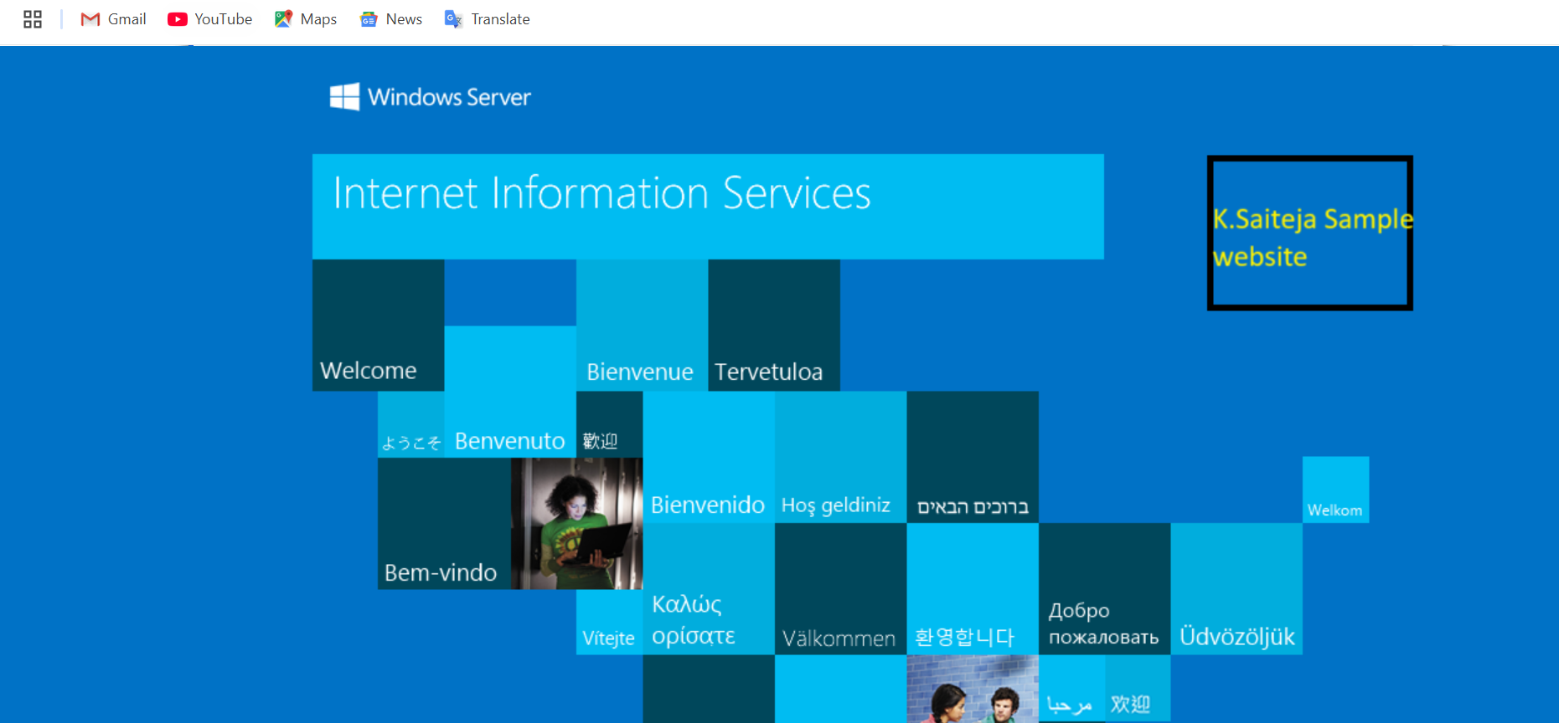

**Reminder: Once the sample website hosting is completed, please delete the files from the S3 bucket to avoid unnecessary storage costs. If the files are kept, AWS will continue to charge based on the storage used, number of requests, and data transfer**